We classified this as scrub based on our criteria of height (still to be determined) and a statement in the paper “Mangrove zones are dominated by R. mangle scrub forest (tree heights 6 1.5 m)”.

1. Aboveground biomass data was from Fig. 5.

Aboveground biomass= Woody biomass + Litterfall biomass.

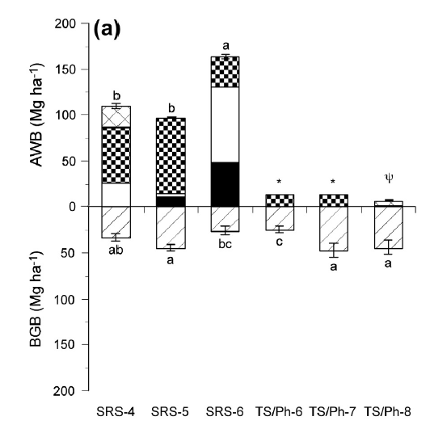

2. Aboveground biomass rate data was from text on page 236 and Fig. 8.

Aboveground NPP= woody NPP + Litterfall NPP;

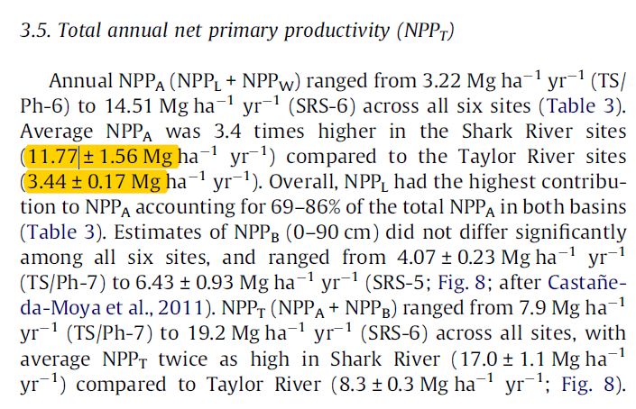

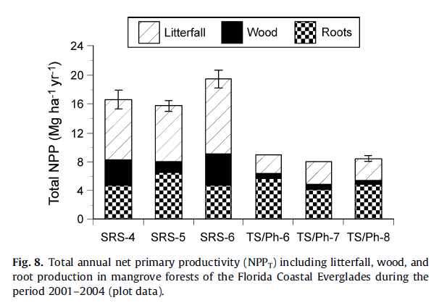

3. Soil C pool data was calculated from bulk density and total C% from Table 1 (page 231).

Soil C pool = Bulk density * Organic C%

SC unit is OC_gcc

